[Color Vision](https://phet.colorado.edu/sims/html/color-vision/latest/color-vision_en.html) **Remote‌ Lab ‌**

(This‌ ‌lesson‌ is designed ‌for‌ ‌a‌ ‌student‌ ‌working‌ remotely‌.)‌

This lab uses the [Color Vision](https://phet.colorado.edu/sims/html/color-vision/latest/color-vision_en.html) simulation from PhET Interactive Simulations at University of Colorado Boulder, under the CC-BY 4.0 license.

<https://phet.colorado.edu/sims/html/color-vision/latest/color-vision_en.html>

**Learning Goals**

1. Describe the color of light that is able to pass through different colored filters.
2. Determine what color the person sees for various combinations of red, green, and blue light.

**Develop your understanding:**

1. Open [Single Bulb](https://phet.colorado.edu/sims/html/color-vision/latest/color-vision_en.html?screens=1) screen, then explore to develop your own ideas about how filters affect how we see light.

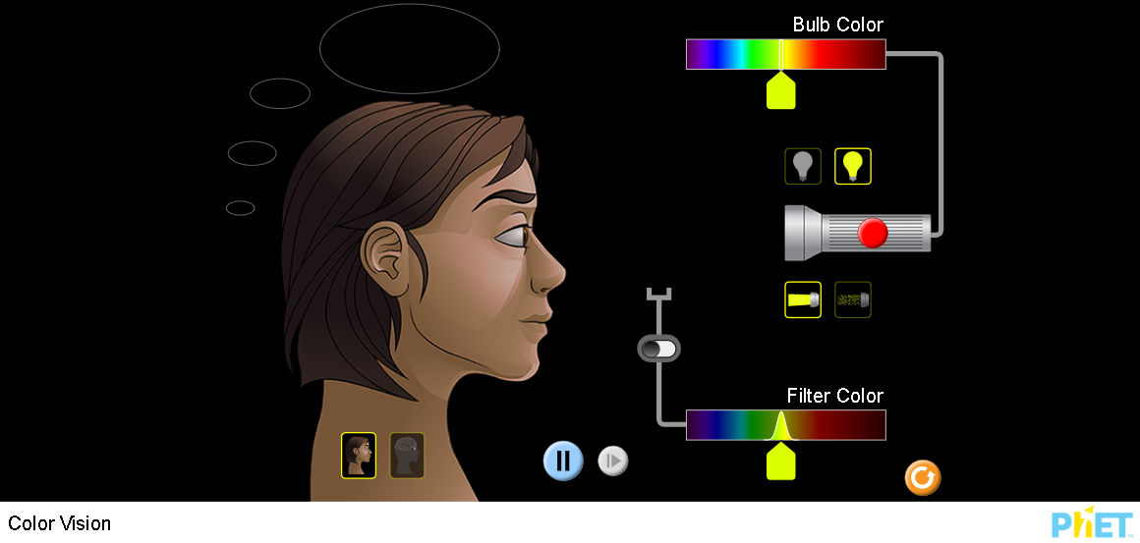

Describe several of your experiments and your observations with captured images from the simulation.

1. .
2. etc

**Explain your understanding:**

2. In the image below, light is displayed as particles called photons. Research to find out what photons are and then explain in your own words why they can be useful for modeling light. (cite references)

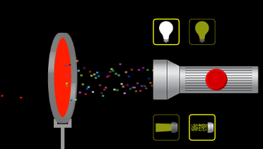

**Demonstrate your understanding:**

3. As you answer the questions,explain in your own words why your answer makes sense and provide evidence from your #1 experiments. Add more experiments to #1 if you need to get better evidence.

1. What colors of light would you see if you look through rose colored glasses?
2. If you are wearing blue sunglasses, what colors would you see if you look at a stop light which is red, yellow, and green at different times?

**Develop your understanding:**

4. Open [Color Vision](https://phet.colorado.edu/sims/html/color-vision/latest/color-vision_en.html?screens=2) screen, then explore to develop your own ideas about how light mixes.

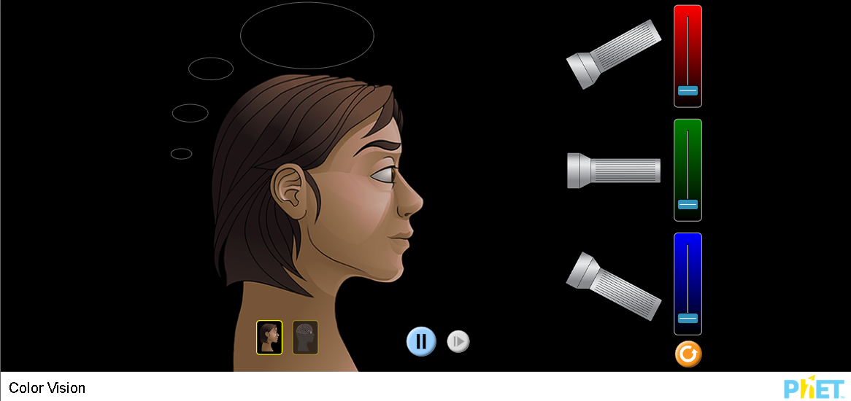

Describe several of your experiments and your observations with captured images from the simulation.

1. .
2. etc

**Explain your understanding:**

5. Why do you think the photon model is used in this screen?

6. Write a question you could ask a fellow student to test their understanding of learning goal B