

Department of Applied Physics and Astronomy
University of Sharjah
Resistance and Resistivity

Name: ID#:
Resistance and Resistivity

Objectives:
1. To study the relationship between the resistance of a wire and its dimensions
2. To know the effect of the type of material on its resistance.
3. To distinguish between resistance and resistivity
4. To find the resistivity of a given wire and from this determine the material

Apparatus:
https://phet.colorado.edu/en/simulation/resistance-in-a-wire
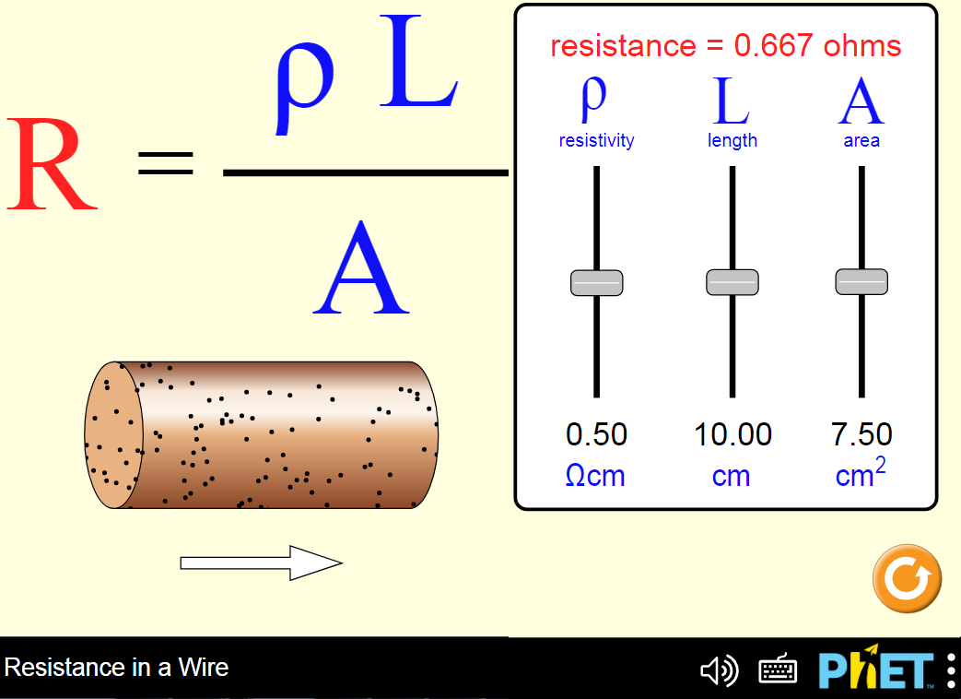

Theory:
Resistivity (ρ) is a fundamental material property, while the resistance (R) of an electrical conducting wire depends on several factors, such as: type of conductor material, length of the conductor, cross-sectional area, and the temperature of the wire.
At a constant temperature, the resistance R of a given conductor is directly proportional to its length L and inversely proportional to its cross-sectional area A.
This resistance is given by the following formula:
$\text{R }=ρ\frac{L}{A}\text{.}\text{.}\text{.}\text{.}\text{.}\text{.}\text{.}\text{.}\text{.}\text{.}\text{.}\text{.}\text{.}\text{.}\text{.}(1)$

Where:
ρ: is the resistivity of the wire material measured by (Ω.m)
L: is the length of the wire
A: is the cross-sectional area of the wire
To study and verify this relation, a PhET Computer Simulation called “Resistance in a Wire” will be used to generate data which can then be graphed using Excel program.

Procedure:
This simulation (https://phet.colorado.edu/en/simulation/resistance-in-a-wire) shows how resistance, resistivity, length and cross-sectional area of a wire are related, in a scenario similar to the “resistance apparatus with wire set” in Physics 2 Lab as shown in Figure 1.
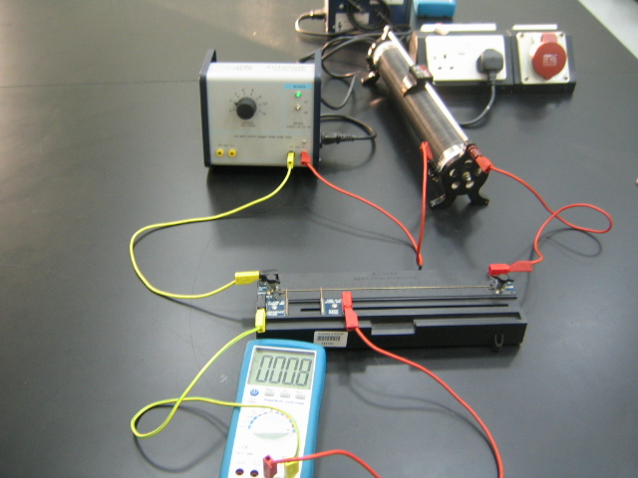

Figure 1

Part 1: Play with the PhET before starting your experiment to see how it works, then answer the following questions:
1- What is the maximum and minimum resistance can be obtained using this system?

R_{max} = …………………...

R_{min} = ……………………

2- Use equation (1) to calculate these values? Show your calculation

R_{max} = ……………………………………………………………………………………

R_{min} = …………………………………………………………………………………….

Part 2: Resistance versus Length
1- Open the following link: https://phet.colorado.edu/en/simulation/resistance-in-a-wire
2- Adjust the resistivity pointer at the midpoint (0.50 Ω.cm) and the area pointer at 7.50 cm².
3- Select the length of the wire 2 cm and take the reading of the resistance R then record the results in Table 1.
4- Repeat step 3 by increasing the length of the wire by 2 cm each time until you fill table 1.
5- Plot the graph of (R versus L), then find the slope.
6- From the slope of the line, find the resistivity of the wire (ρ_{exp})
7- Calculate the percentage error (δ%) of the resistivity

Table 1
Resistivity ρ_{actual} = ……………………

Cross-sectional area A= ……………..

Sr. | Length L  (cm) | Resistance R  (Ω)
1.
2.
3.
4.
5.
6.
7.

1- Draw (R vs. L) using Excel and attach the graph.

2- Does the best straight line pass through the origin? Explain.

………………………………………………………………………………………………

3- From the slope of the line, find the resistivity

ρ_{exp} = …………………………………………………………………….

4- Calculate the percentage error in ρ.

δ% = …………………………………………………………………….

Part 3: Resistance versus Area
1- Open the same link: https://phet.colorado.edu/en/simulation/resistance-in-a-wire
2- Adjust the resistivity at the midpoint (0.50 Ω.cm) and the length at 10 cm.
3- Select the area of the wire around 2 cm² and take the reading of the resistance R.
4- Record the results in data table 2.
5- Increase the area of the wire by 2 cm² each time and repeat previous steps until you fill table 2.
5- Plot the graph of (R versus A), what is the expected shape of this graph?
6- Plot the graph of (R versus 1/A), then find the slope.
6- From the slope of the line, find the resistivity of the wire (ρ_{exp})
7- Calculate the percentage error (δ%) of the resistivity.

Table 2
Resistivity ρ_{actual} = ……………………

Wire length L= ………………..

Sr. | Area A  (cm²) | Resistance R  (Ω) | 1/Area  (cm⁻²)
1.
2.
3.
4.
5.
6.
7.

1- Draw (R vs. A) and (R vs. 1/A) using Excel and attach the graphs.

2- What is the expected shape of (R vs. A) graph? ………………….

3- From the slope of (R vs. 1/A) line, find the resistivity (ρ)

ρ_{exp} = …………………………………………………………………….

4- Calculate the percentage error in ρ.

δ% = …………………………………………………………………….

Questions:
1- What four physical factors affect the resistance of a wire?

………………………………………………………………………………………………

………………………………………………………………………………………………

2- A wire of uniform cross-section has a resistance of R. What would be the resistance of a similar wire, made of the same material, but twice as long and of twice the diameter?

………………………………………………………………………………………………

………………………………………………………………………………………………

3- A block of carbon, 1.0 cm by 2.0 cm by 5.0 cm, has a resistance of 0.015 Ω between its two smaller faces. What is the resistivity of carbon?

………………………………………………………………………………………………

………………………………………………………………………………………………

4- What length of German silver wire, diameter 0.050 cm, is needed to make a 28 Ω resistor, if the resistivity of German silver is 2.2 x 10⁻⁷ Ω.m?

………………………………………………………………………………………………

………………………………………………………………………………………………

5- What is the resistance of one kilometer of copper wire (copper resistivity is 1.68x10⁻⁸ Ω.m), with a diameter of 1.0 cm.

………………………………………………………………………………………………

………………………………………………………………………………………………

6- Conclusions:

………………………………………………………………………………………………

………………………………………………………………………………………………

………………………………………………………………………………………………

………………………………………………………………………………………………

………………………………………………………………………………………………

Answers:

1- Type of material, length of the wire, cross-sectional area and temperature.

2- ¹/₂ R

3- 6.0xl0⁻⁵ Ω.m or (6.0xl0⁻³ Ω.cm)

4- 25 m

5- 0.21 Ω

