
Department of Applied Physics College of Sciences, University of Sharjah

Worksheet of Ohm’s Law by using
PHET Simulation
Student Name: ………………………………………………………………………… ID: …………………………………………….
------------------------------------------------------------------------------------------------------------------------------------------
Title of the Experiment: Ohm’s Law
Objectives:
- To study the relationship between the electric current passing through a resistance and the
potential difference across it.
- Use Ohms’ law to find the equivalent resistance of the different combinations of resistors.
- To distinguish between the Ohmic resistor and the non‐Ohmic resistor.

Apparatus: DC ‐ Power supply, voltmeter, ammeter, resistors, and connecting wires.
Theory and Background:
The electric field inside a conductor equals zero when it is at electrostatic equilibrium, but when the charges move in a conductor they produce an electric current, which is defined by the current density (J). For an Ohmic material the ratio of the current density (J = I/A) and the electric field (E) is constant and equals the conductivity ( σ ). Hence Ohms’ law can be written as:
J = σ E …………..………….. (1)

Where J is the current density, given by: J = I / A
I is the current, A is the cross sectional area of the conductor, E is the electric field and σ is the conductivity of the material, which is equal to inverse of the resistivity of the material (ρ),

σ = (1/ρ)

For a straight wire of cross sectional area (A = π R²; R is the radius of the wire) and length (L) and a potential difference (V) is maintained across it, E is given by the expression:

E = V/ L
Hence:
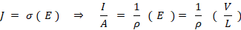
So that:
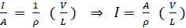
But ,

Hence: $V=\text{RI}$ ……………….. (2)
Resistors are one of the main components of any electric circuit, and some circuits need more than one resistor to produce a high (or low) equivalent resistance. Depending on the purpose for which the circuit is built, resistors can be connected in series or in parallel. For two resistors, R₁ and R₂, the series and parallel connections, and the equivalent resistance, are shown in Figures 1 (a) and 1 (b).
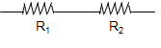
For resistors connected in series:
Figure 1(a)
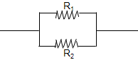
When the resistors are connected in parallel:
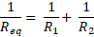

Figure 1(b)
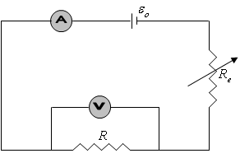
Circuit Connection:
The circuit that we will use is shown in Figure 2
Figure 2: Circuit Diagram
To do the experiment by using PHET interactive simulation follow the following steps:
- Click on the following link from PHET Colorado Simulation
https://phet.colorado.edu/en/simulation/circuit-construction-kit-dc

- Download Circuit Construction Kit: DC
- Click on Lab
- Choose Conventional Current
- Use the components in the left side to build the circuit shown below:
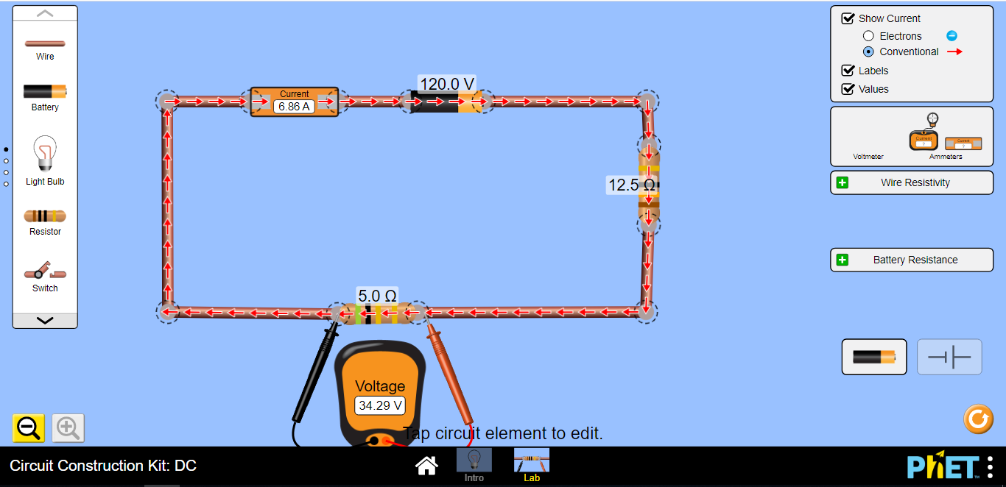
R_{e} (rheostat) Variable resistor
R₁ = 5Ω

- Click on the resistor (R₁) and fix it at 5Ω. That is R₁ = 5Ω.
- Click on the Battery and fix it at 120V.
- Click on the Voltmeter from the right side and drag it to measure (V₁) the voltage across R₁.
- Click on the Ammeter from the right side and drag it and put it in series with R₁ (before or after R₁) to measure (I₁).
- Vary the rheostat () to obtain 6 different readings of the electric current (I) and the corresponding values of the voltage (V). Then Record the values into table 1.
- Replace R₁ by R₂=10Ω as shown below:

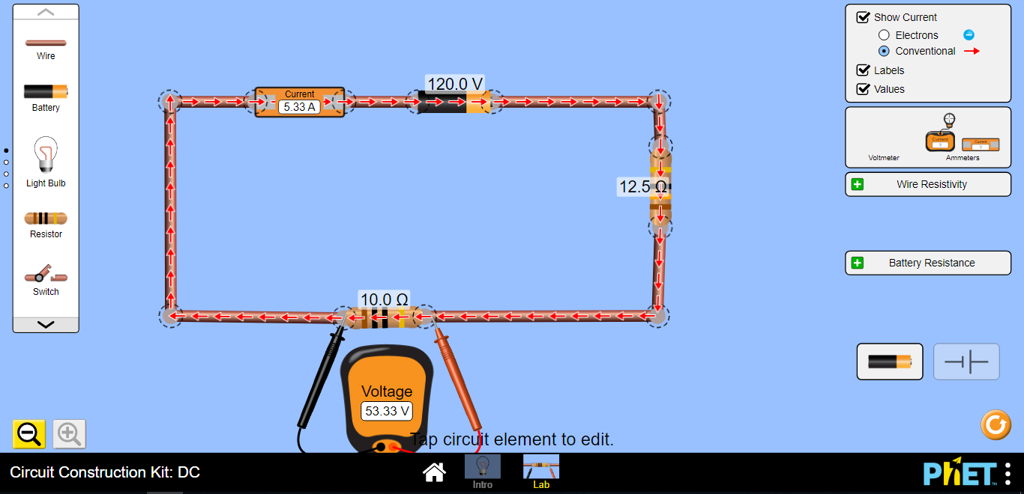

- Again vary the rheostat () to obtain 6 different readings of the electric current (I) and the corresponding values of the voltage (V). Then Record the values into table 1.

- Connect R₁=5Ω and R₂=10Ω in series as shown below, and again vary the rheostat () to obtain 6 different readings of the electric current (I) and the corresponding values of the voltage (V). Then Record the values into table 1.
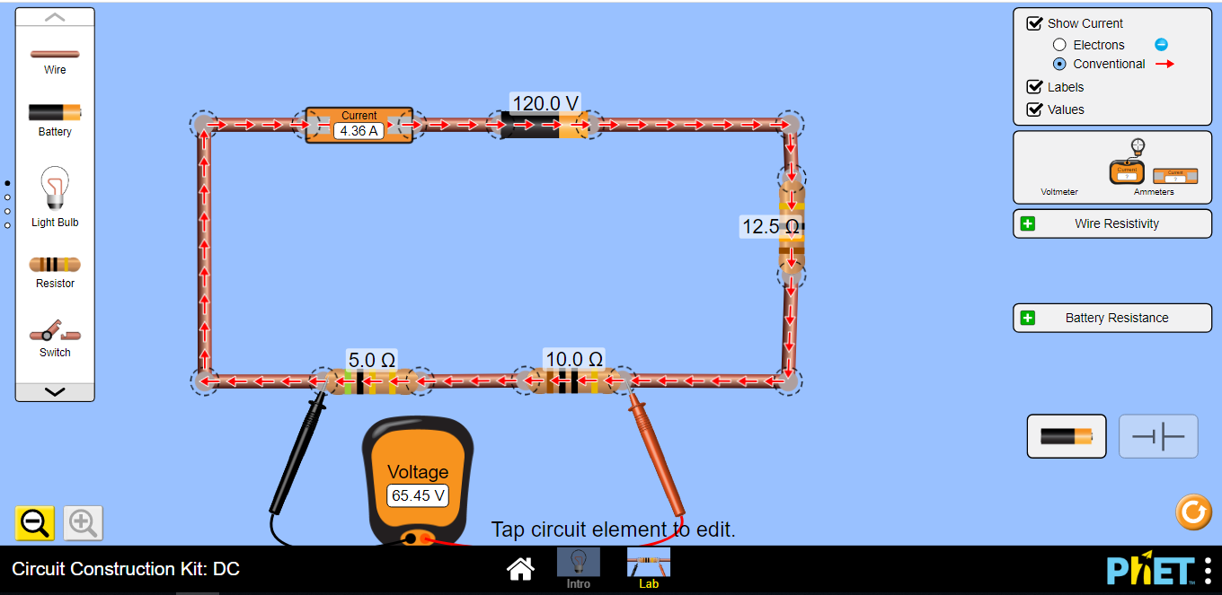
R₁ and R₂ in Series Connection

- Now connect R₁=5Ω and R₂=10Ω in parallel as shown below, and also vary the rheostat () to obtain 6 different readings of the electric current (I) and the corresponding values of the voltage (V). Then Record the values into table 1.
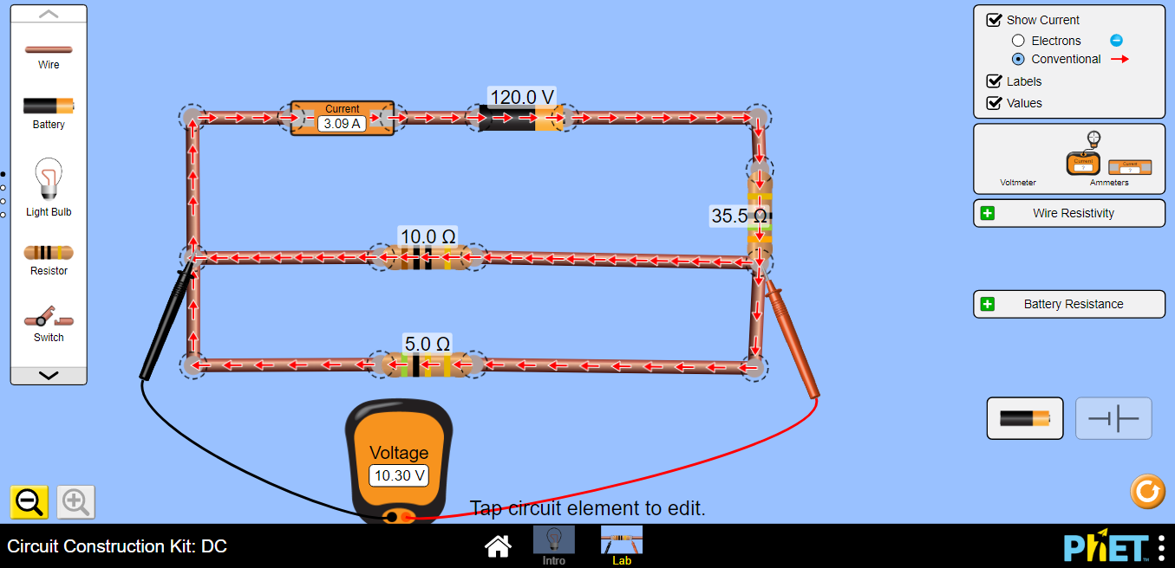
R₁ and R₂in parallel connection

Note that the Voltmeter is always connected in parallel with the element while the Ammeter in series
Table (1)
R₁ (Ω) |  | R₂ (Ω) |  | Equivalent Resistance  in series |  | Equivalent Resistance  in parallel
V(V) | I (A) | V(V) | I (A) | V(V) | I (A) | V(V) | I (A)

  - Plot a graph V versus I for each case?
  - Does the best straight lines passes through the origin? Explain.

  - Calculate the slope of each graph and determine the resistance (R) from the graph (slope) and experimentally? Record the results into table 2.

Table (2)
 | Slope | The experimental Resistance ( Ω ) | δ %
Graph 1 |  | R₁ experimentally =
Graph 2 |  | R₂ experimentally =
Graph 3 |  | R_{eq} experimentally =
Graph 4 |  | R_{eq} experimentally =

  - What is the difference between Ohmic resistor and a Non-Ohmic resistor?

Ohmic:

Non-ohmic

  - When the potential difference, V, across an ohmic resistor is increased what effect does this have on:

  - The electric current (I)

  - The resistance (R)

Conclusions:

