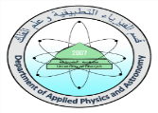

Worksheet (Universal Gravitational Law) Using Phet Interactive Simulation

**Dep. Of Applied Physics and Astronomy University of Sharjah**

**Name : ID#:**

This activity consists of two Parts

Part one: Gravitational force versus distance.

Part two: Gravitational forces versus mass.

To be familiar with the Gravitational force magnitude direction and the parameters affect this force using Phet simulation open the following link and play with it.

<https://phet.colorado.edu/sims/html/gravity-force-lab-basics/latest/gravity-force-lab-basics_en.html>

**Objectives:**

1. Satisfy Universal Gravitational law experimentally
2. Study the parameters that affect the Gravitational force. (distance and mass)

3- Find experimentally the Gravitational constant G.

**Theoretical Background:**

Universal Gravitational Law: “The magnitude of the Gravitational force that an object exerts on another is directly proportional to the product of their masses and inversely proportional to the square of the distancebetween them.” Mathematically, the magnitude of this force FG acting on two objects (m1, m2) is expressed as:

FG=G $\frac{m_{1}m_{2}}{r^{2}}$

Where r is the distance between the objects and G is a constant of proportionality, called the universal gravitational constant, G = 6.67 × 1011 Nm2/Kg2.

**Part one:**

To satisfy the objectives do the following steps.

1. Click on the following link and control the masses of the two objects m1 at 4x109kg and m2 at 6x109kg, record your data in table 1.

<https://phet.colorado.edu/sims/html/gravity-force-lab-basics/latest/gravity-force-lab-basics_en.html>

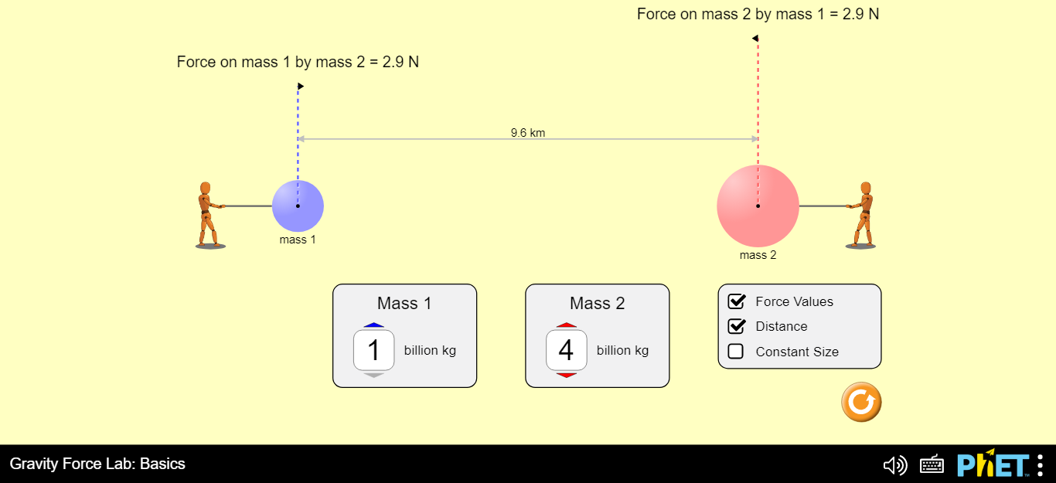

1. Change the distance between the two masses as in shown in the table 1.
2. Record the force value for each distance.
3. Fill table 1 by finding r2 and 1/r2.

Table 1

|  |  |  |  |
| --- | --- | --- | --- |
| **m1= ………….** | | **m2=………….** | |
| **r (km)** | **r2 (km)2** | **1/r2 (1/km)2** | **FG (N)** |
| 9 |  |  |  |
| 8 |  |  |  |
| 7 |  |  |  |
| 6 |  |  |  |
| 5 |  |  |  |
| 4 |  |  |  |
| 3 |  |  |  |

**Part two:**

To satisfy the objectives do the following steps.

1. Click on the following link and adjust the masses m1 at 2x109 kg andthe distance between the two objects r at 5km, write their values in the table 1.

<https://phet.colorado.edu/sims/html/gravity-force-lab-basics/latest/gravity-force-lab-basics_en.html>

1. Change the mass of object 2 as shown in the table 2 and for each mass record the gravitational force between the two objects in table 2.

Table 2

|  |  |
| --- | --- |
| **m1= ………….** | **r = ………….** |
| **m2 (kg)** | **FG (N)** |
| 10x109 |  |
| 9x109 |  |
| 8x109 |  |
| 7x109 |  |
| 6x109 |  |
| 5x109 |  |
| 4x109 |  |
| 3x109 |  |

**Data Analysis**

**Part one:**

1. Uses excel software and plot a graph relates FG and r. comments on the graph.
2. Uses excel and plot one more graph relates FG and 1/r2. Use the graph to find the universal gravitational constant G.

………………………………………………………………………………………………

………………………………………………………………………………………………

………………………………………………………………………………………………

1. Calculate the percentage error in G (Gknown=6.67 × 1011 Nm2/Kg2)

………………………………………………………………………………………………

………………………………………………………………………………………………

………………………………………………………………………………………………

*Note: Attach the graphs to your sheet*

**Part two:**

1. Uses excel software and plot a graph relates FG and m2. Comments on the graph.
2. Use the graph to find the universal gravitational constant G.

………………………………………………………………………………………………

………………………………………………………………………………………………

………………………………………………………………………………………………

1. Calculate the percentage error in k (kknown=6.67 × 1011 Nm2/Kg2)

………………………………………………………………………………………………

………………………………………………………………………………………………

………………………………………………………………………………………………

*Note: Attach the graphs to your sheet*